Charts Finder

###### Charts Finder is an app to get IFR charts for your flights. With a click of a button, you can access thousands of charts all around the world.

## Features

* IFR charts for a wide variety of airports.
* Simple and easy-to-use interface.
* Supports multiple files for one airport.
* Supports different file extensions.
* Highly customizable database for chart resources.
* Translations for the interface.
* An installer and updater.

## Installation & Uninstallation

Download and run the installer for your system (WindowsSetup for Windows, and LinuxSetup for Linux). The installer will install the app step-by-step. On Windows, the installer will make a start menu entry and a desktop shortcut. On Linux, it will make a menu entry.

The app can be uninstalled from Control Panel on Windows like any other app, and by running the ‘maintenancetool’ file in the app installation folder on Linux.

## Usage

Simply enter the ICAO code for the airport you want the charts for. You can enter multiple ICAO codes by separating them with spaces (e.g. HECA OEGS). Click the ‘Get charts’ button. The app will search for the charts and download them if they exist in the resources. If any of the charts is already downloaded, the app will open it by default. You can change this in the settings.

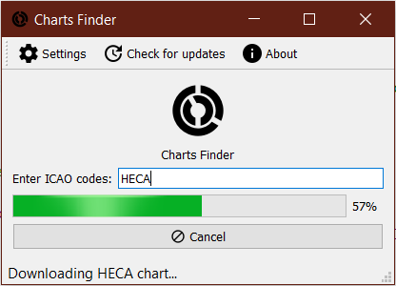

## How it works

There are 2 types of charts: normal charts and folder charts.

Normal charts contain all the airport’s charts in one single file. Folder charts have each chart in a file, so multiple files must be downloaded to complete the airport charts.

Each resource URL contains a placeholder (‘%1’ sign). For normal charts, the app will replace the placeholder with the airport ICAO code and add the resource suffix. For example, if the resource URL is “http://vau.aero/navdb/chart/%1’ and the suffix is ‘pdf’ and the ICAO code is ‘HECA’, the app will download from ‘http://vau.aero/navdb/chart/HECA.pdf’.

For folder charts, the app will replace the placeholder with the airport ICAO code and will download every file that has the resource suffix. Example: if the resource URL is ‘http://www.sia-enna.dz/PDF/AIP/AD/AD2/%1/’ and the suffix is ‘pdf’ and the ICAO code is DAAP, the app will download every PDF file on ‘http://www.sia-enna.dz/PDF/AIP/AD/AD2/DAAP/’ into a folder named ‘DAAP’.

If the charts don’t exist in the resource, the app will move to the next resource until the last resource. For this reason, the resources containing the latest charts should have a higher order (the highest order is 1).

## Settings

###### General

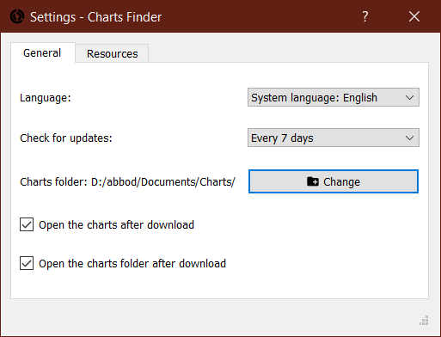

Language: Select the app language. Note that you must restart the app to apply the language change.

Check for updates: Select the update checking interval. If ‘Never’, the app will not check for updates.

Charts folder: Choose the folder that the charts will be downloaded to.

Open the charts after download: The app will open the airport charts file for normal charts, and the airport charts folder for folder charts after they are downloaded.

Open the charts folder after download: The app will open the general charts folder (i.e. the one set in Charts folder) after the download process is completed (e.g. if multiple airports are being downloaded, the folder will be opened after the last one).

###### Resources

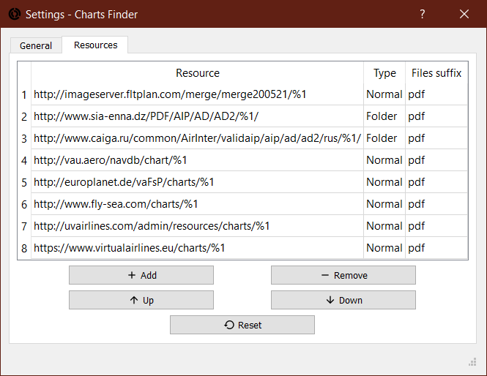

To add a resource, click the ‘Add’ button. The addition window will be opened.

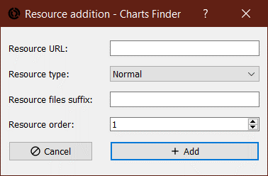

Fill the data as explained in the ‘How it works’ section, then click the ‘Add’ button. If there are incorrect data, the error will be displayed. Otherwise, the window will be closed, and the resource will be added to the list at the specified order.

Select a resource and use the other buttons to change the resource order, remove a resource, or reset the resources to the default ones.

You can also modify a resource by double-clicking the field you want to modify.

## Translations

The user interface can be translated into other languages. The app comes with an Arabic translation, for both the user interface and the manual.

The app uses the Qt translation system. To translate on Windows, you need to download and install [Qt Linguist from Softpedia](https://www.softpedia.com/get/Others/Home-Education/Qt-Linguist.shtml). On Linux, you need to install the ‘qtbase5-dev-tools’ package for Debian/Ubuntu, or the equivalent package for your distribution.

Make a copy of the ‘chartsfinder2_template.ts’ file in the ‘translations’ folder in the app installation folder and rename it by replacing the ‘template’ word with the two-letter [ISO 639-1 language code](https://en.wikipedia.org/wiki/List_of_ISO_639-1_codes) (e.g. ‘chartsfinder2_ar.ts’ for Arabic). Open the file with Qt Linguist and select the target language and begin translating. Don’t forget to mark the translation as done after translating.

Once you have finished translating the file, you need to build the translation so it can be used by the app. From Qt Linguist, click ‘Release’ from the ‘File’ menu. You should find a ‘.qm’ file in the same folder as the ‘.ts’ file. Move that file to the ‘translations’ folder in the app installation if it’s not already there. Open the app and you should see the translation for your language.

You might need to translate the updater, as the updater isn’t a part of the app itself and needs a separate translation. The updater comes with Arabic, German, French, and an outdated Spanish translation. If you want to translate it, download this file and translate it as explained earlier. The filename for Arabic is ‘qtautoupdater_ar.ts’ for example. You need to put the file in the ‘translations’ folder in the app installation folder too.

Also, you can translate this user manual. If you want to do so, don’t translate the words between the quotation marks (‘’) and this section.

If everything works as intended, you can send the file to me so it can be included in the next release. You can do so by [opening an issue on the GitHub repository](https://github.com/abdullah-radwan/ChartsFinder2/issues/new) or sending an email to me. Note that you need to send the ‘.ts’ files for the translation, not the ‘.qm’ files.

## Reporting bugs

If you encountered a problem, try to remove the ‘config.cfg’ file, which is in ‘%appdata%/ChartsFinder2’ on Windows, and ‘~/.local/share/ChartsFinder2’ on Linux. That will reset your settings to the default ones.

If that didn’t fix the problem, [open an issue on the GitHub repository](https://github.com/abdullah-radwan/ChartsFinder2/issues/new) and attach the ‘config.cfg’ and ‘log.txt’ files.

## About

Charts Finder is a free and open-source app under the GPL v3 license. The source code can be found in [the GitHub repository](https://github.com/abdullah-radwan/ChartsFinder2).

Email: [abbodmar@gmail.com](mailto:abbodmar@gmail.com)

Copyright © Abdullah Radwan